**DAILY ONLINE ACTIVITIES SUMMARY**

|  |  |  |  |  |  |  |  |  |
| --- | --- | --- | --- | --- | --- | --- | --- | --- |
| **Date:** | **01/06/2020** | | | | | **Name:** | **NAIPUNYA VINOD NAIK** | |
| **Sem & Sec** | **IV SEM & A SECTION** | | | | | **USN:** | **4AL18CS050** | |
| **Online Test Summary** | | | | | | | | |
| **Subject** | | **COMPLEX ANALYSIS,PROBABLITY AND STATISTICAL METHODS** | | | | | | |
| **Max. Marks** | | **30** | | **Score** | | | **26** | |
| **Certification Course Summary** | | | | | | | | |
| **Course** | **INTRODUCTION TO CYBERSECURITY** | | | | | | | |
| **Certificate Provider** | | | **GREAT LEARNING ACADEMY** | | **Duration** | | | **7 HRS** |
| **Coding Challenges** | | | | | | | | |
| **Problem Statement:1)** [Given an array arr[] of size N and an integer K. The task is to find the count of subarrays such that each subarray has exactly K distinct elements.](https://github.com/orgs/alvas-education-foundation/teams/2nd-year/discussions/90)  2)Write a Java program to Define a class Point with two fields x and y each of type double. Also , define a method distance(Point p1, Point p2) to calculate the distance between points p1 and p2 and return the value in double.. Use Math.sqrt( ) to calculate the square root.  3) [Given an array of positive integers. Write a C Program to find the leaders in the array.](https://github.com/orgs/alvas-education-foundation/teams/2nd-year/discussions/92) | | | | | | | | |
| **Status: EXECUTED** | | | | | | | | |
| **Uploaded the report in Github** | | | | | **YES** | | | |
| **If yes Repository name** | | | | | <https://github.com/naipunya-naik/lockdown-coding/blob/master/JAVA%20CODING/distancebetweenthepints_01-06-2020.java>  <https://github.com/naipunya-naik/lockdown-coding/blob/master/JAVA%20CODING/distinctelements_01-06-2020.java>  <https://github.com/naipunya-naik/lockdown-coding/blob/master/C%20CODING/leaders%20in%20array_01-06-2020.c> | | | |
| **Uploaded the report in slack** | | | | | **YES** | | | |

Online Test Details: (Attach the snapshot and briefly write the report for the same).

THE 3RD I.A TEST OF COMPLEX ANALYSIS , PROBABILITY AND STATISTICAL METHODS WAS CONDUCTED ON 1 JUNE 2020.

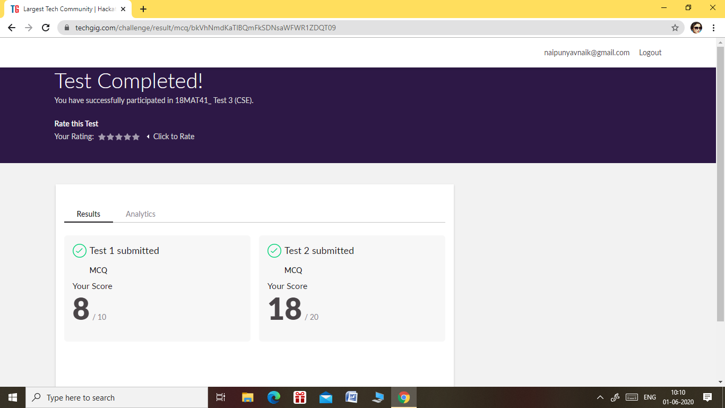

* SUBJECT:- COMPLEX ANALYSIS ,PROBABILITY AND STATISTICAL METHODS
* SYLLABUS:- MODULE 5
* START TIME:- 9.30 AM
* END TIME:- 10.10 AM
* DURATION:- 40 MIN
* NO.OF QUESTIONS:TEST 1:-10 QUESTIONS
* NO.OF QUESTIONS:TEST 2:-10 QUESTIONS
* THE 3RD I.A TEST COMPRISED OF TWO TESTS, TEST 1 AND TEST 2.
* TEST 1 :- EACH QUESTION CARRIED 1 MARK.
* TEST 2:- EACH QUESTION CARRIED 2 MARKS

Certification Course Details: (Attach the snapshot and briefly write the report for the same)

CERTIFICATION COURSE NAME:- INTRODUCTION TO CYBERSECURITY



TOPICS COVERED ON 01 JUNE 2020:-

* SECURE SYSTEM DESIGN
* THREATS AND VULNERABILITIES
* WHAT IS CYBERSECURITY?

Coding Challenges Details: (Attach the snapshot and briefly write the report for the same)

PROBLEM STATEMENT:- Write a Java program to Define a class Point with two fields x and y each of type double. Also , define a method distance(Point p1, Point p2) to calculate the distance between points p1 and p2 and return the value in double.. Use Math.sqrt( ) to calculate the square root.

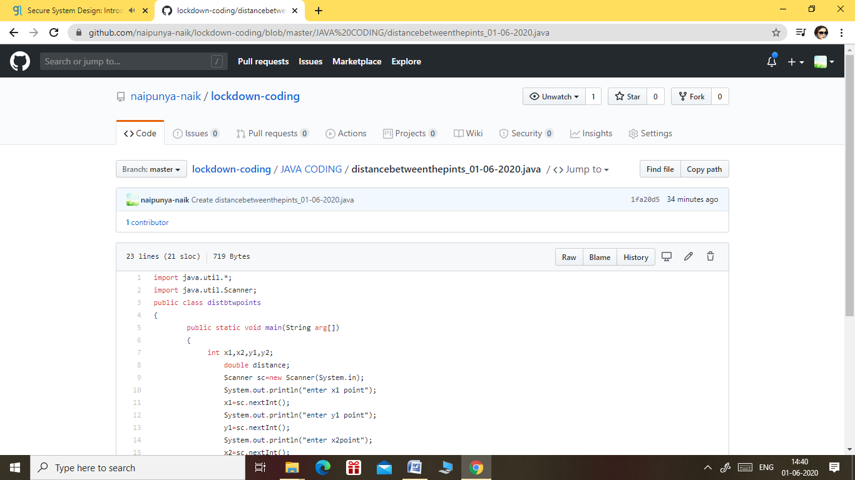

GITHUB REPOSITORY LINK:-

<https://github.com/naipunya-naik/lockdown-coding/blob/master/JAVA%20CODING/distancebetweenthepints_01-06-2020.java>

2) [Given an array arr[] of size N and an integer K. The task is to find the count of subarrays such that each subarray has exactly K distinct elements.](https://github.com/orgs/alvas-education-foundation/teams/2nd-year/discussions/90) Examples: Input: arr[] = {2, 1, 2, 1, 6}, K = 2 Output: 7 {2, 1}, {1, 2}, {2, 1}, {1, 6}, {2, 1, 2}, {1, 2, 1} and {2, 1, 2, 1} are the only valid subarrays

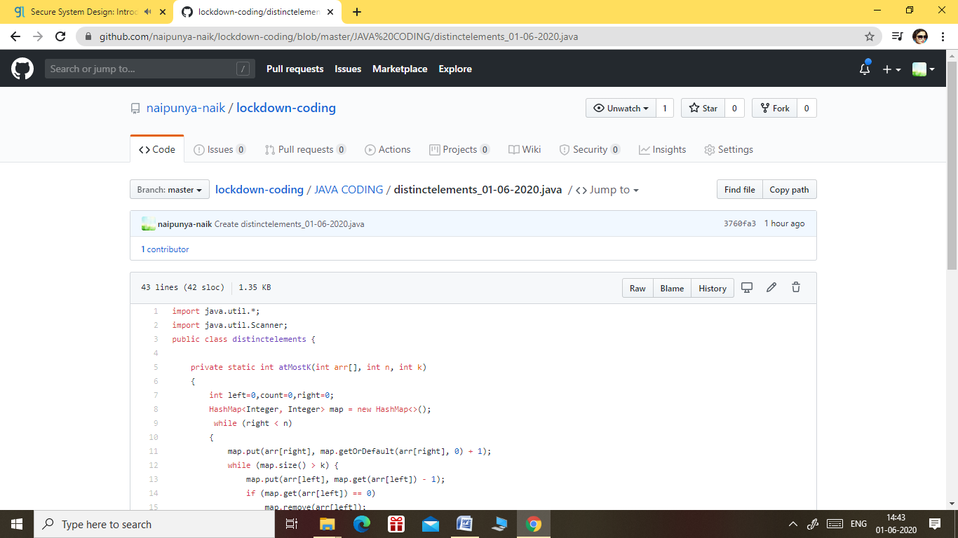

GITHUB REPOSITORY LINK:-

<https://github.com/naipunya-naik/lockdown-coding/blob/master/JAVA%20CODING/distinctelements_01-06-2020.java>

PROBLEM STATEMENT 3) [Given an array of positive integers. Write a C Program to find the leaders in the array.](https://github.com/orgs/alvas-education-foundation/teams/2nd-year/discussions/92)

**Note:** An element of array is leader if it is greater than or equal to all the elements to its right side. Also, the rightmost element is always a leader.

**Input:**  
The first line of input contains an integer T denoting the number of test cases. The description of T test cases follows.  
The first line of each test case contains a single integer N denoting the size of array.  
The second line contains N space-separated integers A1, A2, ..., AN denoting the elements of the array.

**Output:**  
Print all the leaders.

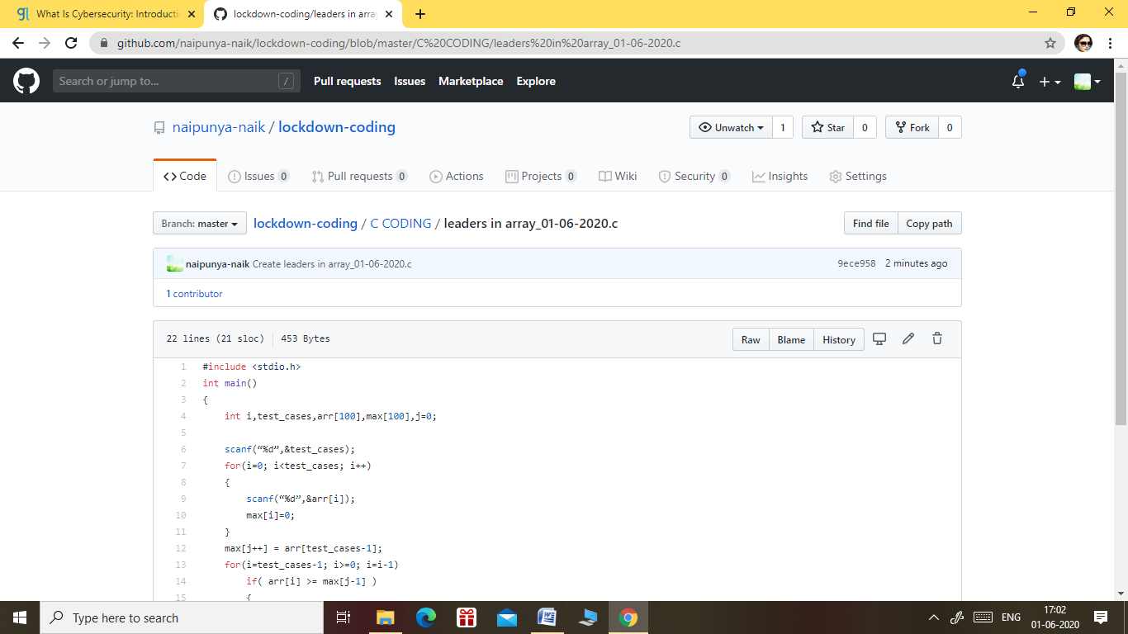

GITHUB REPOSITORY LINK:-

<https://github.com/naipunya-naik/lockdown-coding/blob/master/C%20CODING/leaders%20in%20array_01-06-2020.c>